Task 3.1 Geophysical drivers of bio diversity across sea scapes at each habitat for each BBT. Contribution to WP2 fact sheet for each broad belt transect.

It is intended to use Emodnet to define each substrate (or habitat) type and if practical for each type, extract information on geophysical parameters. Emodnet , considers depth, optical properties, salinity, Waves, currents, oxygen , temperature and Ice cover as being the main geophysical drivers, which seem sensible. It is intended to use Emodnet data or the Copernicus satellite, CMEMS model output for each of these.

Task for each broad belt transect lead is to identify if there are better data sets than the one I propose.

Broader – task is it substrate type or EUNIS 2019 classification that should be used to define the habitat type and if so which of level ( 4 -6 are the biotic ones).

|  |  |  |
| --- | --- | --- |
| **Name – Large scale water column** |  | Likely source |
| Temperature  Salinity , ice cover (Baltic only) | Bed  Surface, mean, min max, | Copernicus Marine Data store European North West Shelf Ocean Physics and Analysis (NWES)  <https://data.marine.copernicus.eu/product/NORTHWESTSHELF_ANALYSIS_FORECAST_PHY_004_013/description>  Mediterranean <https://data.marine.copernicus.eu/product/MEDSEA_MULTIYEAR_PHY_006_004/description>  Baltic https://data.marine.copernicus.eu/product/BALTICSEA_REANALYSIS_PHY_003_011/description |
| Oxygen  Ph | Near bed  Mean, Min, max. | NWES https://data.marine.copernicus.eu/product/NORTHWESTSHELF_ANALYSIS_FORECAST_WAV_004_014/description  Mediterranean <https://data.marine.copernicus.eu/product/MEDSEA_MULTIYEAR_BGC_006_008/description>  Baltic https://data.marine.copernicus.eu/product/BALTICSEA_REANALYSIS_BIO_003_012/description |
| Light |  | EMODNET-KD, |
|  |  |  |
| Wave field Mean, Min Max |  | NWES https://data.marine.copernicus.eu/product/NWSHELF_REANALYSIS_WAV_004_015/description  Mediterranean https://data.marine.copernicus.eu/product/MEDSEA_ANALYSISFORECAST_WAV_006_017/description  Baltic https://data.marine.copernicus.eu/product/BALTICSEA_REANALYSIS_WAV_003_015/description |
| Kinetic Energy at bed,  Currents |  | EmodNET, North Sea, Med - Lacking Baltic sea (needs to be derived). |
| KE at bed due to waves |  | Emodnet , North Sea. – Need to derive products for Med, Baltic - from Copernicus data |
| Sea bed substrate |  | EMOD NET - see figure below. |
| HABITAT type |  | What level ? |

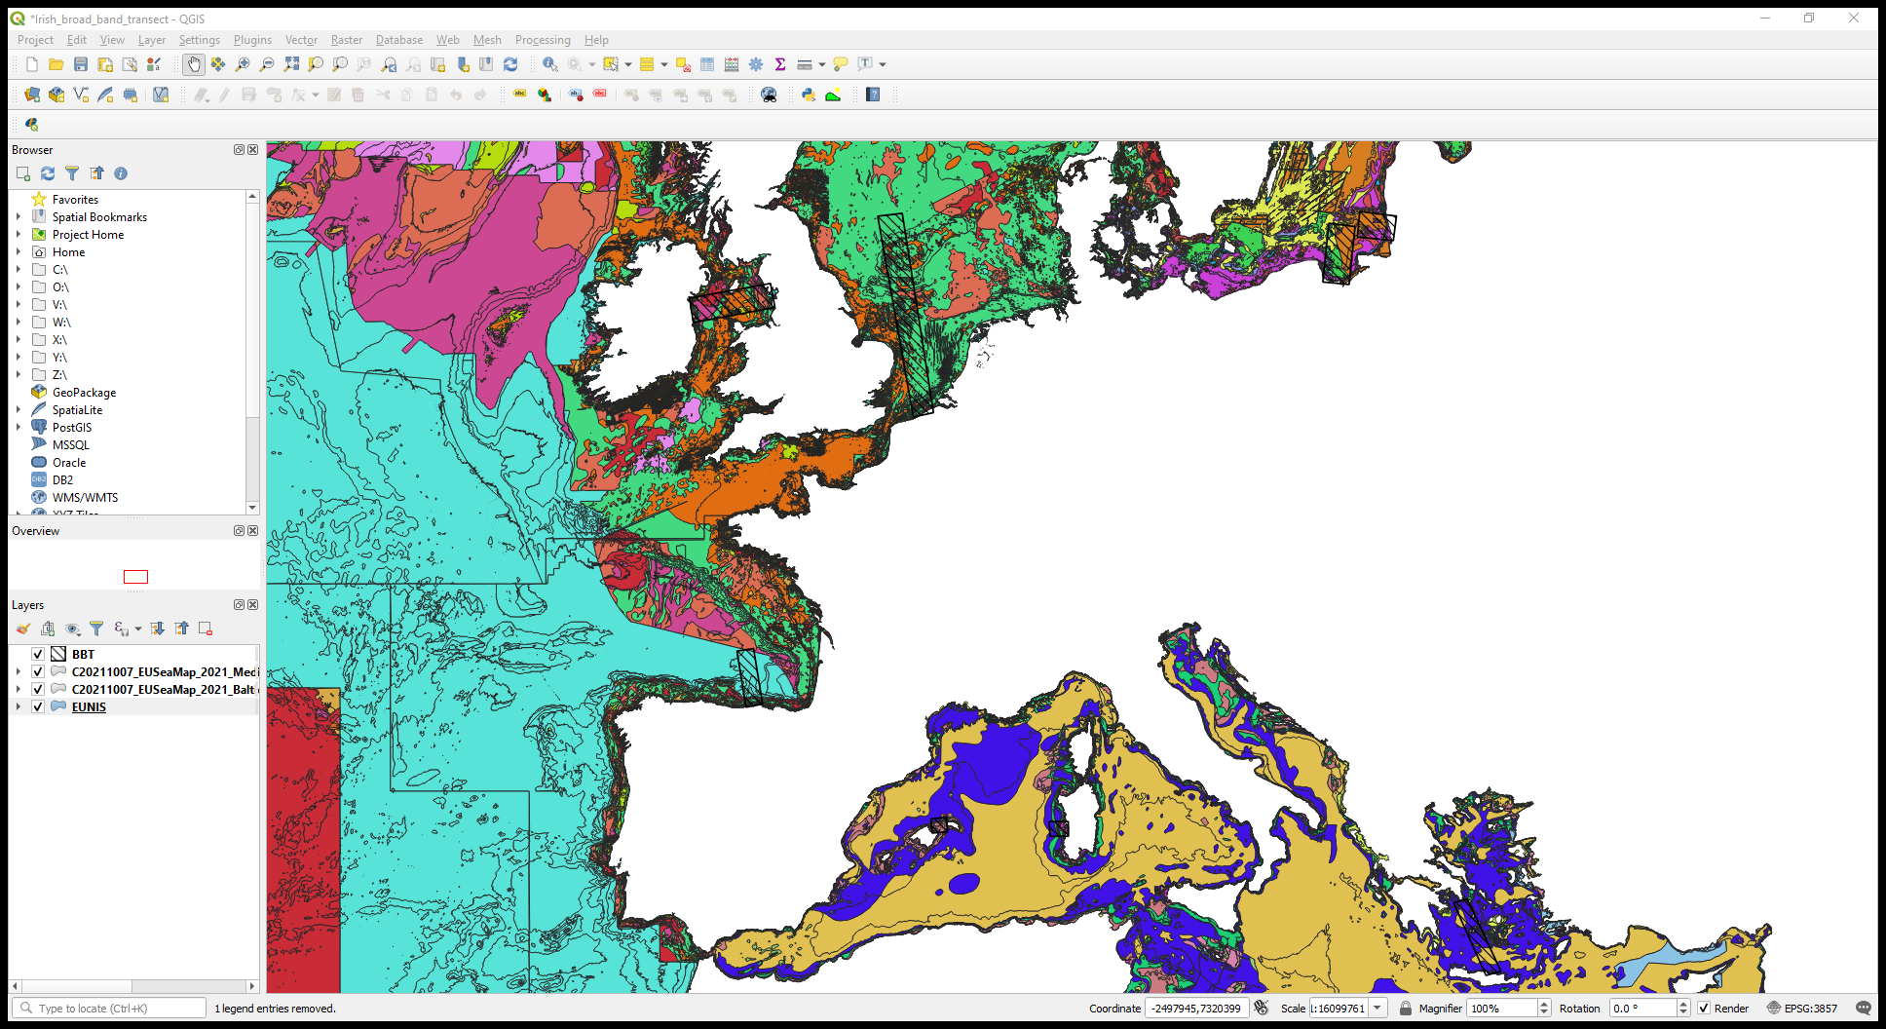

EUNIS Substrate classification for the Broad belt transects. Note the colour classifications for the substrate type are not consistent across the NWES, Baltic and Mediterranean.